Huffman Tree Report
This Huffman tree program was created to compress basic txt files into binary digits in order to take up less space and be more optimized then just storing the ascii values of each character. A standard ascii character is 8 bits that need to be stored per character, however after the compression they can just take up a couple bits depending on how many unique characters your file has. This program can also be faster than standard .txt files because when its outputting the ascii characters it will be searching with O(n) which is fairly quick. The program demonstrates a more practical application of data structures such as trees and hash maps.
Data compression can be used to help reduce storage needs and Huffman trees are a widely used version of compression. The standard ASCII encoding in TXT files designates 8 bits of data per character. In contrast the Huffman tree assigns shorter binary codes to more frequent characters and longer codes to infrequent ones. This allows the compressed texts to be highly efficient. The algorithm first counts character frequencies in the file, builds a binary tree, generates the binary codes for reach character, and finally encodes and decodes data using the tree.
The program is implemented using several data structures: Unordered maps (unordered_map<char, int>) these store the frequency of each character with an average O(1) for each insertion and lookup. A priority queue of the min heap variety which stores tree nodes by frequency and has a O(log n). Lastly a binary tree is used where each leaf node represents a character and the internal nodes store combined frequencies.
Workflow:
Step 1: Frequency Table is created
The entire file is converted into a string, and each character is counted and stored in a hash map
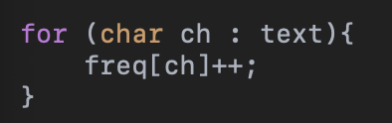
Step 2: Min Heap is built
Each character becomes a node and each node is inserted using a priority queue based on frequency of the character in the text
Step 3: Huffman Tree
Repeats until all nodes are inserted in their proper place:
Removes two smallest nodes
Merges into parent node
Reinserted into the heap
This has a time complexity of O(n log n)

Example of Huffman Tree:
(char, freq) A:5, B:2, C:1, D:1
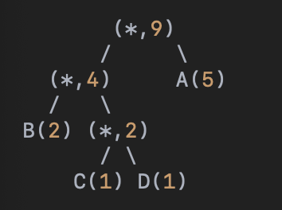

Step 4: Code Generation
The codes are then generated recursively with a left edge -> 0, and a right edge -> 1. From the example above A would be 1, B -> 00, C -> 010, D -> 011.
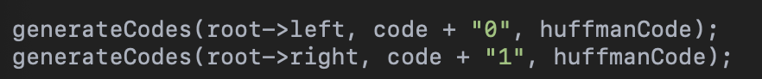

Step 5: Encoding
The input text is traversed and each character is replaced with the Huffman code representing it. Time complexity of o(n)

Step 6: Decoding
The tree is traversed using the bits that are inputted, and when a leaf is reached the character is outputted. Time complexity of O(n).

Files are handled using ifstream to read the input file and output is handled by ofstream. Memory is managed by dynamically allocating tree nodes. ASCII encoding is a standard 8 bits per character however this Huffman algorithm typically encodes between 1-5 bits. The best case is then the data uses a lot of the same characters, and the worst case is when all characters are used. Some of the limitations in this program is that it outputs directly to a text file, so the compression isn’t completely realized since it’s not saved to a buffer. The tree is also not saved next to the text so it can’t be reused. This is something I am looking to add in the future. By using various data structures, I was able to effectively create a Huffman encoder and decoder that outputs to text files and takes in text files.

